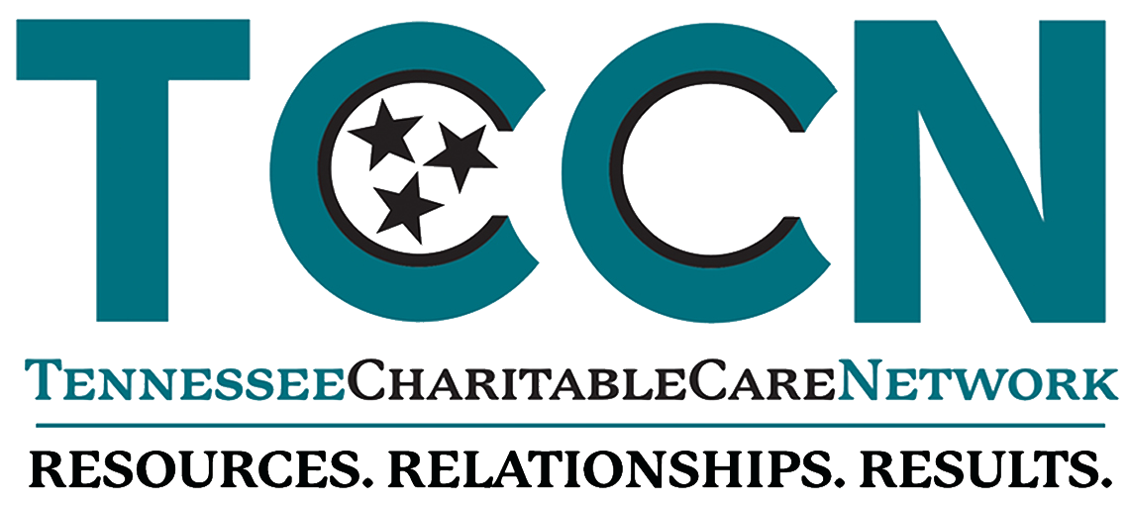

Request for Proposals #2021-01
Equity Vaccination Project

- Introduction
Tennessee Charitable Care Network is releasing this competitive Request for Proposal (RFP) to increase COVID-19 vaccination uptake in high-risk, minority, and underserved communities across Tennessee. This project is funded under a Grant Contract with the State of Tennessee, Department of Health.

- Funding Opportunity
This funding is intended to support statewide and/or local efforts to address COVID-19 vaccine hesitancy and access to vaccination, especially in under-represented communities and high-risk areas. TCCN’s health equity vaccination project will deploy specially designed interventions for ensuring that Tennesseans disproportionately affected by COVID-19 make it to the finish line of having accurate accessible information and requisite assistance to secure an appointment, transportation, as needed and ultimately have the COVID-19 vaccine administered. The populations targeted by this project include the unhoused, uninsured, rural, homebound and those that lack transportation options and computer literacy, with an emphasis on people in racial and ethnic minority groups.

TCCN is seeking proposals to provide the services outlined in this RFP. TCCN will offer grants of between $3,000 and $5,000 depending on the number of applications received. TCCN reserves the right to adjust the total amount of the grants depending upon available funding. This project period is expected to begin October 1, 2021, until March 30, 2022.

This effort will be supported by Sostento, a 501c3 organization. Sostento will work with TCCN by collecting and reviewing clinic feedback, developing operational interventions and other vaccine related access support activities to be deployed by the awarded applicants.

Deliverables:
All awardees will be expected to complete the following activities and deliverables below:

- Reports
- Provide brief monthly progress reports on basic activity metrics (see Data Collection section)
- Submit a final report describing stakeholder collaboration, successes, challenges, lessons learned, event and activity metrics.

- Activities to be conducted
- Participate and engage with other free and charitable clinics on the Project Finish Line Facebook page.
- Submit monthly progress updates on your clinic's vaccination activities (administering vaccines and/or scheduling vaccine appointments).
- Attend support hours for additional consultative services from the Sostento team, when needed.
- Implement digital tools and services provided by TCCN and Sostento to increase COVID-19 vaccine access.
- Participate on a three-phase strategic approach to conduct community conversations that will yield new tailored tools and services needed to reach the goals of the project
- Participate in the review of existing clinic feedback related to this initiative.
- Conduct a new survey of individuals who receive services in their clinic to collect insights on their reasons for vaccine hesitancy and the barriers that stop them from taking the vaccine.
- Implement campaigns, digital tools and services provided by TCCN and Sostento as part of the initiative.
- Provides data related with clients served under this initiative as requested.

- Participation to meetings or webinars
- Attend or view the recording of the Equitable Vaccination Network monthly webinars.
- Participate in regularly scheduled conference calls with other sub-awardees and subject matter experts to share progress on activities and discuss lessons learned.

- Data collection
- Number of individuals helped to get vaccinated
- Number of individuals that reach HelplineSOS
- Challenges faced each month and how the clinic overcame them, if applicable
- Successes this clinic had each month
- Number and types of people reached by events/campaigns promoting COVID-19 vaccination
- Number of individuals reached by activities (i.e. number of individuals attending/listening sessions, number of campaigns launched, etc.)
- Eligibility Information
Eligible applicants are TCCN organizational members that have both demonstrated experience and current capacity to engage communities of unhoused, uninsured, rural, homebound and those that lack transportation options and computer literacy at increased risk of COVID-19 infection and mortality with culturally competent outreach and education activities.

- Submitting a Proposal & Questions
To respond to this RFP, please submit the proposal online via the link below no later than 5:00 pm CST on September 24, 2021. Applicants will receive an email notification of receipt.

Link for RFP

Please note the following:
- Only one proposal will be accepted per applicant.
- The proposal should be submitted on pdf format and should be signed by an authorized officer.
- The proposal should not exceed 5 pages and must use 12-point font.

All questions concerning this RFP must be sent to Grants@tccnetwork.org in writing on or before September 15, 2021. TCCN’s responses will be emailed to all applicants.

- Evaluation Criteria
Domain | Selection Criteria | Score
Problem Statement | The proposal describes the service area.  The applicant outlines demographics and characteristic of the target population.  The proposal describes the current need and severity. | 20 points
Project Description | The applicant describes their community involvement.  The applicant specifies collaborations and partnerships relevant to this project.  The applicant has prior experience with similar projects.  The proposal describes key personnel to be assigned to this project and their level of expertise. | 40 points
Outputs/Outcomes | The proposal describes how data will be collected to be able to complete the reports required. | 20 points
Funding Request | The proposal includes a funding request and describes the use of the funds. | 20 points
Total |  | 100 points

- Timeline
September 10, 2021 | RFP release
September 15, 2021 | Deadline to send questions by email
September 17, 2021 | TCCN response to written questions
September 24, 2021 | RFP submission deadline, 5:00 pm CST
September 29, 2021 | Selection notification
October 1, 2021 | Finalize agreement
October 1, 2021 | Effective start date of contract
October 1, 2021 | Project Kickoff Call
October 1, 2021 - March 31, 2022 | Implementation period

*Please note that the timeline is subject to change

